KAKATIYA INSTITUTE OF TECHNOLOGY AND SCIENCES, WARANGAL

A Major Project Report
on
"VOICE-CONTROLLED AI STUDY ASSISTANT"
(An AI-Powered NotebookLM-Style Learning Platform)

Submitted in partial fulfilment of the requirements
for the award of the degree of
BACHELOR OF TECHNOLOGY
in
COMPUTER SCIENCE AND ENGINEERING (AI & ML)

Academic Year: 2025–26

Submitted by
Maram Sai Shashank Raj
Roll No.: B24AI185

Under the guidance of
Prof. Maram Balajee
Professor, Department of Computer Science and Engineering, SR University, Warangal
Department of Computer Science and Engineering (AI & ML)
Kakatiya Institute of Technology and Sciences, Warangal

June 2026

BONAFIDE CERTIFICATE
This is to certify that the Major Project Report entitled "VOICE-CONTROLLED AI STUDY ASSISTANT" submitted by Maram Sai Shashank Raj (Roll No.: B24AI185) in partial fulfilment of the requirements for the award of the degree of Bachelor of Technology in Computer Science And Engineering (Ai & Ml) is a bonafide record of work carried out by him under my supervision and guidance.
The matter embodied in this report has not been submitted elsewhere for the award of any other degree or diploma.

Date: June 2026
Place: Warangal
Signature of the Guide
Prof. Maram Balajee
Professor, Department of Computer Science and Engineering, SR University, Warangal

PROJECT APPROVAL SHEET
The Major Project Report entitled "VOICE-CONTROLLED AI STUDY ASSISTANT" submitted by Maram Sai Shashank Raj has been examined and approved for submission.
Name | Roll Number | Signature
Maram Sai Shashank Raj | B24AI185

Project Guide: Prof. Maram Balajee Date: June 2026
Internal Examiner: _____________________ Date: __________
External Examiner: _____________________ Date: __________

DECLARATION
I, Maram Sai Shashank Raj, hereby declare that the Major Project Report entitled "VOICE-CONTROLLED AI STUDY ASSISTANT" submitted to Jawaharlal Nehru Technological University, Hyderabad through Kakatiya Institute of Technology and Sciences, Warangal in partial fulfilment of the requirements for the award of the degree of Bachelor of Technology in Computer Science And Engineering (Ai & Ml) is an authentic record of my own work carried out under the supervision of Prof. Maram Balajee.
The matter embodied in this report has not been submitted by me for the award of any other degree or diploma. Wherever other works have been referred to, due acknowledgement has been made.

Date: June 2026
Place: Warangal

Signature of the Student: _________________________
Maram Sai Shashank Raj

ACKNOWLEDGEMENT
I express my sincere gratitude to my project guide, Prof. Maram Balajee, Professor, Department of Computer Science and Engineering, SR University, Warangal, for invaluable guidance, continuous encouragement, and constructive feedback throughout the development of this project.
I thank the faculty members of Department of Computer Science and Engineering (AI & ML), Kakatiya Institute of Technology and Sciences, Warangal, for providing academic support and laboratory facilities.
I acknowledge OpenRouter, DeepSeek, Google Gemini, Mozilla pdf.js, AntV, and the open-source community for tools and APIs that made this project feasible.
Finally, I thank my parents and friends for their moral support and motivation.

ABSTRACT
Traditional study methods often require students to manually organize notes, search across multiple documents, and switch between reading, revision, and assessment tools. Generic AI chatbots provide answers but lack source grounding, persistent notebooks, and integrated study workflows inspired by modern research assistants such as Google NotebookLM.
This project presents a Voice-Controlled AI Study Assistant — a full-stack web application deployed at https://voice-study-assistant.vercel.app/ that enables students to upload study sources (PDF/text), interact through text and voice, and generate rich learning artifacts including mind maps, slide decks, flashcards, FAQs, briefing documents, study outlines, data tables, study resource roadmaps, and infographics. The system uses DeepSeek v3.2 via OpenRouter for conversational AI, JSON-based chat responses on Vercel serverless, Google Gemini TTS for multilingual speech output, and the Web Speech API for speech-to-text input.
The application follows a three-panel NotebookLM-inspired interface: Sources, Chat, and Studio. User authentication is implemented using stateless JWT-based identity derivation, with per-user data isolation in browser localStorage. Experimental evaluation demonstrates successful deployment, multilingual query handling, and effective generation of study materials from uploaded sources.
Keywords: Artificial Intelligence, Voice-Controlled Systems, Natural Language Processing, Study Assistant, OpenRouter, Speech-to-Text, Text-to-Speech, NotebookLM, Web Application, Vercel.

TABLE OF CONTENTS
CHAPTER 1 – INTRODUCTION
CHAPTER 2 – LITERATURE SURVEY
CHAPTER 3 – SYSTEM ANALYSIS
CHAPTER 4 – DESIGN METHODOLOGY
CHAPTER 5 – IMPLEMENTATION
CHAPTER 6 – RESULTS AND DISCUSSION
CHAPTER 7 – CONCLUSION AND FUTURE SCOPE
REFERENCES
APPENDICES

LIST OF FIGURES
Fig. 3.1 System Architecture Overview
Fig. 4.2 Data Flow Diagram – Level 0
Fig. 5.1 Authentication Page
Fig. 5.2 Main Three-Panel Interface
Fig. 5.3 Chat Interface with Saved Studio Outputs
Fig. 5.4 Interactive Mind Map Output
Fig. 6.1 Chat Response with Action Buttons and Code Explanation

LIST OF ABBREVIATIONS AND ACRONYMS
Abbreviation | Expansion
AI | Artificial Intelligence
API | Application Programming Interface
CSS | Cascading Style Sheets
DFD | Data Flow Diagram
HTML | HyperText Markup Language
JWT | JSON Web Token
LLM | Large Language Model
NLP | Natural Language Processing
PDF | Portable Document Format
SSE | Server-Sent Events
STT | Speech-to-Text
SVG | Scalable Vector Graphics
TTS | Text-to-Speech
UI | User Interface

CHAPTER 1

INTRODUCTION

1.1 Introduction to Artificial Intelligence
Artificial Intelligence (AI) refers to the simulation of human intelligence in machines programmed to think, learn, and solve problems. In education, AI enables personalized tutoring, automated content summarization, intelligent question answering, and adaptive learning pathways.

1.2 Voice-Controlled Systems Overview
Voice-controlled systems allow users to interact with software through spoken commands. The Web Speech API enables browser-native speech recognition and synthesis, supporting hands-free learning during revision sessions.

1.3 Need for AI-Based Study Assistants
Students manage multiple subjects, PDFs, lecture notes, and revision schedules simultaneously. An integrated AI study assistant combines source management, grounded chat, voice interaction, and automated study artifact generation in one workspace.

1.4 Problem Statement
The problem addressed is the lack of an affordable, deployable AI study platform that grounds responses in user-uploaded sources, supports voice and multilingual output, generates diverse study materials, persists notebooks across sessions, and isolates data between users.

1.5 Motivation of the Project
Commercial platforms such as Google NotebookLM demonstrate the value of source-grounded AI for learning. This project builds a college-level, deployable alternative using OpenRouter, modern web technologies, and a NotebookLM-inspired user experience.

1.6 Objectives of the Project
- Design and implement a web-based AI study assistant with NotebookLM-style three-panel layout.
- Integrate voice input (STT) and voice output (TTS) for hands-free learning.
- Enable PDF/text source upload and source-grounded AI chat.
- Implement Studio features: mind maps, slides, flashcards, FAQ, briefing, outline, data tables, study resources, and infographics.
- Provide audio overview podcasts with interactive join-conversation and continue-in-podcast modes.
- Implement user authentication with per-user data isolation.
- Deploy the application on Vercel at https://voice-study-assistant.vercel.app/.

1.7 Scope of the Project
Scope includes frontend UI, backend API proxy, OpenRouter LLM integration, authentication, local persistence, and cloud deployment. Custom LLM training and native mobile applications are out of scope.

1.8 Proposed Solution
The proposed system is a full-stack web application with Vanilla JavaScript frontend, Node.js/Express backend on Vercel, OpenRouter for LLM/TTS, JWT stateless authentication, and localStorage-based notebook persistence scoped per user.

1.9 Applications of the System
- Engineering exam preparation
- Competitive exam revision
- Research paper summarization
- Multilingual language learning
- Classroom AI demonstration
- Remote mentoring via shared link

1.10 Advantages of the Proposed System
- Unified workspace for sources, chat, and study content
- Voice and text multimodal interaction
- Low cost via Vercel and OpenRouter pay-per-use
- Browser-based — no installation
- Rich studio outputs beyond plain chat
- Per-user data isolation

1.11 Organization of the Report
Chapter 2 presents literature survey. Chapter 3 covers system analysis. Chapter 4 describes design. Chapter 5 explains implementation. Chapter 6 discusses results. Chapter 7 concludes with future scope.

CHAPTER 2

LITERATURE SURVEY

2.1 Introduction
This chapter reviews voice assistants, AI in education, speech technologies, NLP approaches, and comparative systems.

2.7 Comparative Analysis of Existing Systems
System | Source Grounding | Voice | Study Artifacts | Custom Deploy
Google NotebookLM | Yes | Limited | Audio, slides | No
ChatGPT | Via uploads | Yes (Plus) | Generic | No
Proposed System | Yes | Yes (STT+TTS) | Mind map, flashcards, podcast | Yes (Vercel)

2.9 Summary
Literature review confirms demand for integrated AI study platforms. The proposed system fills gaps by combining NotebookLM-inspired UX, voice control, rich studio outputs, and practical deployment.

CHAPTER 3

SYSTEM ANALYSIS

3.3 Proposed System
The proposed Voice-Controlled AI Study Assistant is deployed at https://voice-study-assistant.vercel.app/ with authentication, multi-notebook management, source upload, AI chat, Studio generation, audio overview, explain/translate/speak actions, and saved outputs.

3.5.1 Hardware Requirements
Component | Specification
Client PC/Laptop | Intel i3 or equivalent, 4 GB RAM
Microphone | Built-in or external
Network | Broadband internet

3.5.2 Software Requirements
Software | Purpose
Chrome / Edge 90+ | Web browser
Node.js 18+ | Local development
OpenRouter API Key | LLM and TTS access
Vercel | Cloud deployment

3.8 System Architecture Overview
The system follows three tiers: Presentation (HTML/CSS/JS + Web Speech API), Application (Express.js on Vercel serverless), and External Services (OpenRouter DeepSeek/Gemini). Data persists in browser localStorage keyed by user ID.
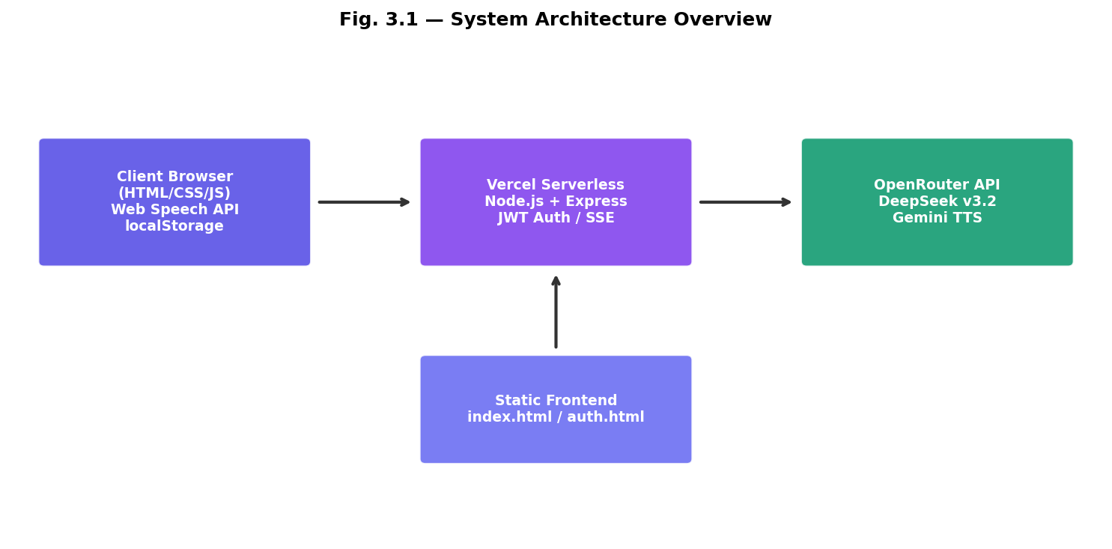
Fig. 3.1 — System Architecture Overview

CHAPTER 4

DESIGN METHODOLOGY

4.2 Architecture of the Proposed System
Monorepo: frontend/ (static) and backend/ (server.js). Vercel routes /api/* to serverless backend. config.js switches API_BASE between localhost and same-origin production.

4.3 Module Description

4.3.1 Voice Input Module
Web Speech API captures microphone input; final transcript sent to chat pipeline.

4.3.2 Speech-to-Text Module
Browser STT with regex-based language detection for Telugu, Hindi, Tamil, and other scripts.

4.3.3 NLP Processing Module
LLM prompt orchestration injects sources, notes, and chat history into OpenRouter requests.

4.3.4 AI Response Generation Module
POST /api/chat returns JSON on Vercel; SSE streaming used locally.

4.3.5 Data Storage Module
localStorage keys: sa_auth, sa_notebooks_v2_<uid> for notebooks, sources, chats, studioOutputs.

4.3.6 User Interface Module
Three-panel layout: Sources | Chat | Studio with premium auth.html login page.

4.4 Data Flow Diagram
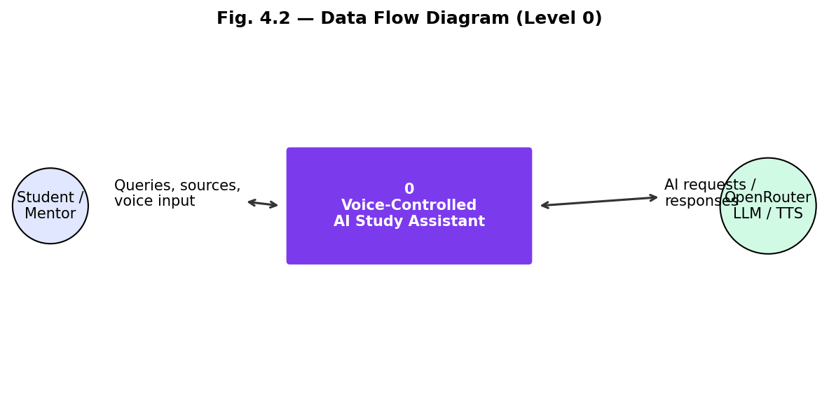
Fig. 4.2 — Data Flow Diagram (Level 0)

4.5 Use Case Diagram
Actors: Student, Mentor, OpenRouter API. Use cases: Sign Up, Sign In, Upload Source, Chat (Text/Voice), Generate Mind Map, Slides, Flashcards, Audio Overview, Explain, Translate, Save Output, Sign Out.

4.11 Security and Privacy Considerations
- API key stored only in server environment variables
- JWT HS256 with 365-day expiry
- Per-user localStorage isolation
- HTTPS via Vercel

CHAPTER 5

IMPLEMENTATION

5.2 Development Environment
Development on Windows with VS Code/Cursor. Local backend on port 3000. Production at https://voice-study-assistant.vercel.app/ via Vercel CLI.

5.3 Tools and Technologies Used
Category | Technology | Purpose
Frontend | HTML5, CSS3, JavaScript | UI and client logic
Backend | Node.js, Express.js | REST API
AI | DeepSeek v3.2 via OpenRouter | Chat and generation
TTS | Gemini 3.1 Flash TTS | Multilingual speech
PDF | pdf.js | Text extraction
Mind Map | SVG + Reingold-Tilford | Interactive maps
Deployment | Vercel | Static + serverless

5.8 User Authentication Process
Stateless auth: uid = HMAC(email + password). JWT stored in localStorage. Mentor login via username ss6156. Auth guard redirects unauthenticated users to auth.html.

5.10 Screenshots of Implementation
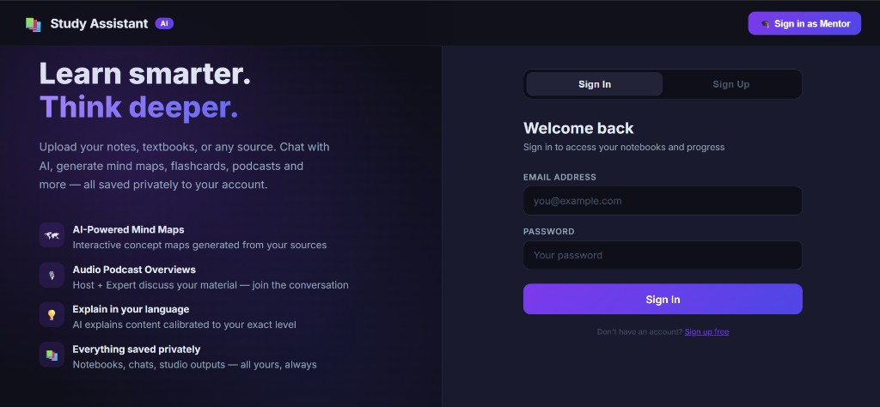
Fig. 5.1 — Authentication Page with Sign In / Sign Up and Mentor Portal

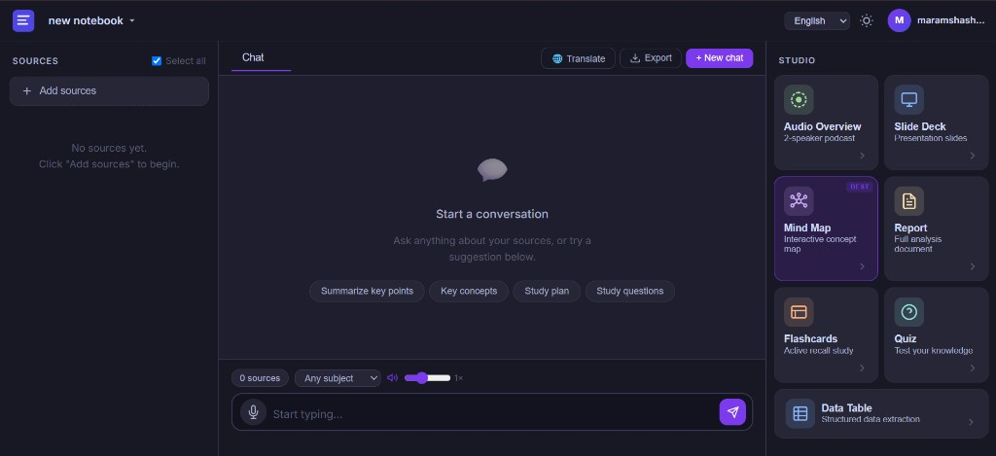
Fig. 5.2 — Main Three-Panel Interface (Sources | Chat | Studio)

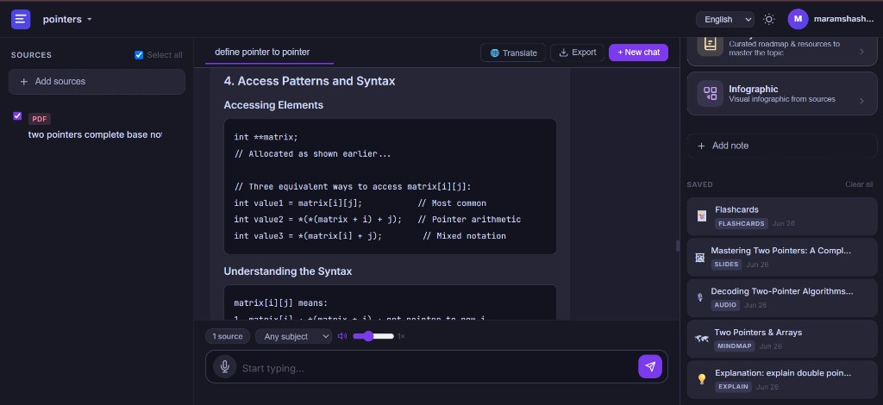
Fig. 5.3 — Chat Interface with Saved Studio Outputs Panel

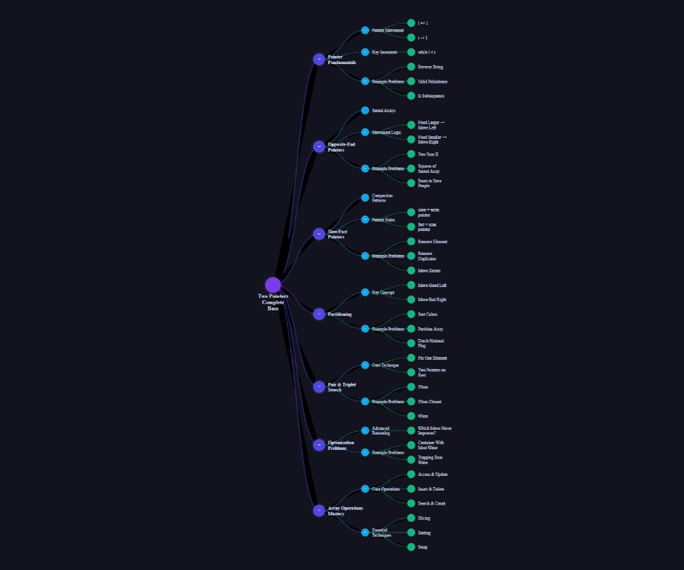
Fig. 5.4 — Interactive Mind Map Generated from PDF Source

CHAPTER 6

RESULTS AND DISCUSSION

6.2 Test Cases
TC ID | Test Case | Result
TC-01 | User sign-up with email | Pass
TC-02 | User sign-in — notebooks loaded | Pass
TC-03 | Upload PDF source | Pass
TC-04 | Chat query on source (pointer to pointer) | Pass
TC-05 | Voice input query | Pass
TC-06 | Generate mind map | Pass
TC-07 | Generate flashcards, slides, audio | Pass
TC-08 | Explain / Translate / Speak buttons | Pass
TC-09 | Cross-device Vercel access | Pass
TC-10 | Mentor login | Pass

6.5 Response Time Analysis
Operation | Average Time
Sign-in API | 1–6 seconds
Full chat response | 15–25 seconds (Vercel)
Mind map generation | 15–30 seconds
PDF extraction (20 pages) | 3–8 seconds

6.8 Discussion of Results
The system successfully demonstrates NotebookLM-style learning at https://voice-study-assistant.vercel.app/. Uploading 'two pointers complete base' PDF and querying 'define pointer to pointer' produced accurate C/C++ code explanations with saved mind maps, flashcards, slides, and audio outputs visible in the Saved panel.

6.9 Limitations
- Data in localStorage — not synced across devices
- No vector RAG for very large PDFs
- Vercel cold starts cause initial delay
- STT accuracy varies by browser

CHAPTER 7

CONCLUSION AND FUTURE SCOPE

7.1 Conclusion
The Voice-Controlled AI Study Assistant successfully delivers an integrated AI-powered learning platform at https://voice-study-assistant.vercel.app/, combining source-grounded chat, voice interaction, studio artifacts, audio podcasts, and user authentication.

7.2 Achievements
- Full-stack NotebookLM-style UI implemented
- DeepSeek v3.2 integrated via OpenRouter
- 10+ studio features built
- Voice input and TTS output working
- Deployed on Vercel with authentication
- Complete project documentation prepared

7.3 Future Enhancements
- Cloud database for cross-device sync
- Vector RAG for large documents
- Mobile PWA app
- Collaborative group notebooks

7.5 Final Remarks
This project demonstrates that modern LLM APIs, browser speech technologies, and serverless deployment can build sophisticated educational tools suitable for academic demonstration and real-world learning.

REFERENCES
[1] Google, NotebookLM: An AI-powered research and writing assistant, Google Labs, 2023–2024.
[2] OpenRouter, OpenRouter API Documentation, https://openrouter.ai/docs, 2024.
[3] DeepSeek, DeepSeek-V3 Technical Report, 2024.
[4] Mozilla, pdf.js Documentation, https://mozilla.github.io/pdf.js/, 2024.
[5] W3C, Web Speech API Specification, 2024.
[6] Vercel, Serverless Functions Documentation, https://vercel.com/docs/functions, 2024.
[7] IETF RFC 7519, JSON Web Token (JWT), 2015.
[8] Russell, S., and Norvig, P., Artificial Intelligence: A Modern Approach, 4th ed., Pearson, 2020.

APPENDICES

Appendix A – Source Code Structure
voice-study-assistant/
├── frontend/ (index.html, auth.html, app.js, styles.css, mindmap.js)
├── backend/ (server.js, package.json)
├── vercel.json
└── README.md

Appendix D – User Manual
1. Open https://voice-study-assistant.vercel.app/
2. Sign up with email and password
3. Create a notebook and upload PDF/text sources
4. Ask questions via text or microphone
5. Use Studio cards to generate mind maps, slides, flashcards, etc.
6. Click Speak, Explain, or Translate on AI responses
7. Access saved outputs in the Saved panel
8. Sign out via avatar in top bar

Appendix E – Installation Guide
Local: cd backend && npm install && node server.js. Serve frontend/ statically.
Deploy: vercel --prod from project root with OPENROUTER_API_KEY set.

ANNEXURES
Annexures (Project Synopsis, Weekly Progress Reports, Gantt Chart, Plagiarism Report, Guide Logbook, and Completion Certificate) are submitted separately to the department as per institute norms.

